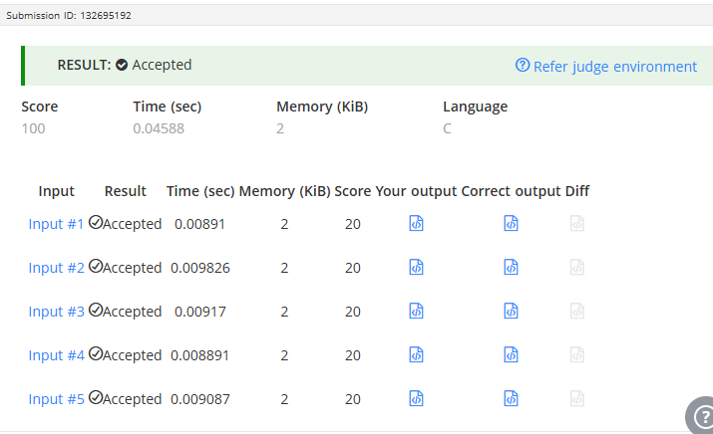

CODE –

#include <stdio.h>

int main() {
int T, N, first, last;

scanf("%d", &T);

for (int i = 0; i < T; i++) {
scanf("%d", &N);

last = N % 10;

while (N >= 10) {
N = N / 10;
}

first = N;

printf("%d\n", first + last);
}

return 0;
}

LINK –
https://www.hackerearth.com/problem/algorithm/digit-sum-4/

